# **Contrast as a Principle of Design**

## **Contrast in Art**

**Contrast** is one of the fundamental [principles of art](https://study.com/learn/lesson/principles-of-art-elements-examples-what-are-the-principles-of-art.html). It is the pairing of elements that are opposite from one another. Without contrast, everything in a work of art would be the same, such as a fully white canvas. Contrast draws the eye from place to place and allows artists to create **focal points**, or areas of high visual interest. In this way, contrast ties in heavily with composition. Contrast's art definition is relevant in every kind of art, from traditional art and graphic design to interior design.

## **The Contrast Principle of Design**

Art would be significantly less appealing without this one of the many key principles of design: contrast. Examples include opposites such as light and dark, color and lack of color, angles and curves, high detail and low detail. It can also involve opposite, or complementary, colors, such as red and green, blue and orange, or yellow and purple. Contrast is the opposite of [unity](https://study.com/learn/lesson/unity-in-art-design-examples-whatis-unity-variety-in-art.html) because contrast calls for things to be different from one another while unity requires sameness.

There are many ways an image can incorporate contrast. Here are a few:

* Space: Images can have areas of positive and negative space that break up the composition and draw the eye in different directions.
* Color: Contrasting colors stand out from one another, having the same effect as the contrast between positive and negative space.
* Shape: Variations in shape size, shape number, and type of shape can all be a form of contrast.
* Distance: The foreground or background can be blurry, exaggerating the illusion of depth in an image and drawing focus to what is clear.
* Detail: Objects rendered in greater detail can create focal points within an image because there is more to look at in areas of greater detail.
* Texture: Different textures can break up visual space or create differing levels of detail between areas (a swatch of fur versus a matte surface, for example).

### **Contrast in Visual Arts**

Contrast has been used in traditional art for as long as artists have been making art. However, some of the most striking examples of contrast lie in the paintings of the Romantic era of art.

Henry Fuseli's *The Nightmare*, created in 1781, utilizes the principle of contrast on multiple levels. The first and most obvious example is in the use of lights and darks throughout the painting. Much of the painting is dark or even black, while the woman that sleeps in the bed is bathed in light. This draws a great deal of visual attention to the woman and the thing that sits on her chest. Fuseli also contrasts color when depicting the impish figure and the woman. The woman wears mostly white and has very pale skin, while the impish figure is a muddy color, and very dark in comparison.

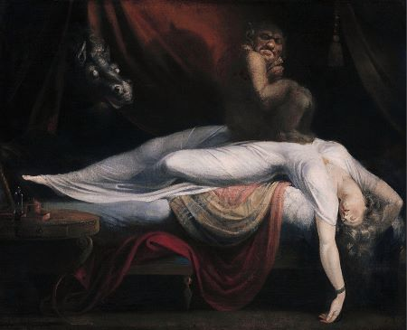

Fuseli also contrasts beauty against ugliness in this painting. The surrounding scene, while mostly dark, is elegant and contains luxurious fabrics and draperies that form flowing lines throughout the painting, implying a pleasant-looking interior. The woman also portrays a sense of beauty both in her appearance and in the dynamic pose she holds. The other figures, while not taking up much space in the composition, provide a stark counterpoint to the beauty because of their strangeness.

### **Contrast in Graphic Design**

Contrast's graphic design definition involves contrast less in the sense of light and dark like in the previous example and instead relies on contrast through color, line, form, size, and space. In graphic design, contrast must be used in order to direct attention or dissect information. As mentioned previously, one of the key purposes of contrast is to create a focal point, and this remains the same here. However, graphic design often needs to be more direct in this approach. The graphic designer's goal is often to grab and maintain attention for their piece.

The image here could be an excellent cover image for a magazine or an article, as there is plenty of empty space for text or captions or be used to separate information between its two halves. This image has several elements of contrast going on at once. The first and most obvious element of contrast is color. The blue and the yellow stand out from each other, allowing the eye to bounce from one side of the image to the other. The other is the contrast of detail. Much of the canvas for this image is blank, containing only one of two colors. However, the center of the image shows two colored pencils, breaking up the space and creating a focal point in the center of the image that has the added effect of leading the eye to the point of each pencil. Because of the way the image is split into halves that contrast so much, it makes for a great attention-grabber.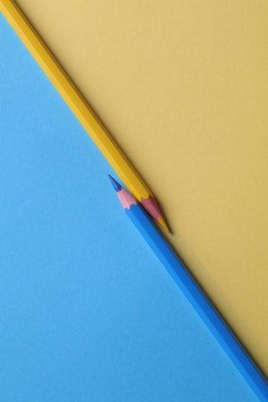

Another important aspect of graphic design is the typeface. This too can have contrasting elements, from differences in case (upper case versus lower case), size of the font, and type of the font (serif, sans serif, script). Using different kinds of font can help break up information on a page and make certain areas more enticing for the eye by including a large, bold, uppercase title with contrasting smaller lowercase font.

### **Contrast in Interior Design**

Contrast in interior design follows many of the same principles as mentioned previously, however it is not limited by the same constraints of composition. In interior design, contrasts between textures, shapes, colors, and spaces are all key components.

In this image, much of the room is wood paneling, creating a sameness of texture and color throughout. In order to break up that unity, rugs and mats have been added to the flooring, such as the faux-fur rug by the couch and the dark gray doormat at the back of the room. Additionally, the space utilizes larger furniture to not only help break up the space into different parts (a living area towards the right of the photograph and a study area or dining area on the right) but also provides a great deal of contrast from the lighter tans and browns of the rest of the space. It is also smooth in texture and color, offering little variation in contrast to the wood which has a great deal of variety within its limited palette of wood tones.